**EXCEL ASSIGNMENT 6**

1. What are the various elements of the Excel interface? Describe how they're used.

***Title Bar****– contains the name of the workbook. The default is Book1 (and then Book2, etc.). This is replaced by the filename once the Excel workbook is saved.*

***Worksheet Tabs****– a list of all the worksheets in the workbook. By default, these are labeled Sheet1, Sheet2, etc. You can navigate to any worksheet in the workbook by clicking on that worksheet tab. You can also use the four small arrows to the left of the worksheet tabs for navigation purposes. The first arrow is used to go to the first worksheet, the second to go to the previous worksheet, the third to go to the next worksheet and the fourth to go to the last worksheet. You can change the name of any of the worksheets by doubling clicking on its tab and then entering a new name. You can add a new worksheet by clicking on the rightmost worksheet tab icon You can also change the order of the worksheets in the list by left-clicking on a worksheet tab and dragging it to a new location in the list. You can access other capabilities by right-clicking on any of the worksheet tabs or the worksheet tab arrows.*

***Ribbon Tabs****– the top-level menu items. In the example above this consists of****Home, Insert, Page Layout, Formulas****, etc. The actual choices can change depending on the state that you are in. To access most capabilities in Excel you click on one of these ribbon tabs. For each tab, a different ribbon will be displayed. In Figure 1 the****Home****ribbon is displayed. This tab provides access to the most common Excel capabilities.*

***Ribbon****– a collection of Excel capabilities organized into****groups****corresponding to some ribbon tab. For example, the****Home****ribbon displayed in Figure 1  is organized into the****Clipboard, Font, Alignment, Number****, etc. groups. Each group consists of one or more****icons****corresponding to some capabilities in Excel. For example, to center the content of a cell in a worksheet, click on that cell and then click on the center icon  in the Alignment group on the Home ribbon. We use the following abbreviation for this sequence of steps:****Home > Alignment|Center****.*

*In a similar manner, you can merge two neighboring cells by highlighting the two cells and selecting****Home >***

***Alignment|Merge & Center****; the two cells are combined and any content placed in the merged cell will be centered. Also, cells, rows, columns, and worksheets can be inserted, deleted, and formatted using****Home > Cells****. There are also shortcuts for some icons. E.g., to center the contents of a cell, you can click on that cell and then enter****Ctrl-E****. To get some idea of the purpose of an icon, place the mouse pointer over that icon (without clicking) and a tooltip will appear to provide some information about the icon. Some of the groups on a ribbon are accompanied by a small arrow (to the right of the name of the group). When you click on this arrow you will be presented with a dialog box that provides you with various options to choose from. E.g. clicking on the arrow for the Font group on the Home ribbon brings up a dialog box with tabs labeled****Number, Alignment, Font, Border****, etc. Each tab in the dialog box presents you with a different set of options for formatting the range of cells that are currently highlighted in the worksheet. For example, to specify that you want numbers in the highlighted cells to be displayed with 3 decimal places, you select the****Number****tab and then the****Number****option and finally fill in 3 in the box specifying the number of decimal places. Some icons within a group are also accompanied by a small downward arrow. When you click on this arrow you will be presented with a vertical list of options. E.g. clicking on the****Insert****icon in the****Cells****group in the****Home****ribbon brings up the choices****Insert Cells…****,****Insert Sheet Rows****,****Insert Sheet Columns****,****Insert Sheet****.*

*Some groups also contain scrollable drop-down lists accompanied by a downward arrow. E.g. clicking on the arrow to the right of the****Font****drop-down list in the****Font****group on the****Home****ribbon, presents a scrollable list of available fonts (Arial, Time New Roman, etc.) to choose from.*

***Office Button****– the icon in the upper left side of the Excel 2007 interface that allows you to open, save and print workbooks. When you click on this icon you will be presented with a menu of options. In addition to opening, saving and printing workbooks, there is a button called****Excel Options****. Clicking on this button displays a dialog box that offers you the ability to change various configuration parameters.  It also contains the****Add-In****option that we will describe later.*

*Excel 2010 and later versions of Excel do not use the Office Button. Instead, they provide the same functionality using the****File****tab. The****File****tab is the first ribbon tab in versions of Excel starting with Excel 2010 and is located to the left of the****Home****tab.*

***Quick Access Toolbar****– contains frequently used icons and is located in the upper left-hand corner of the display (just to the right of the Office Button in Excel 2007 and above the****File****and****Home****tabs in versions of Excel starting with Excel 2010). Initially, the toolbar contains the****Save, Repeat****and****Undo****icons. You can add or delete icons from this toolbar by clicking on the small downward arrow at the right end of the toolbar to display a customization dialog box.*

***Active Cell****– displays the currently referenced cell. This is the cell that you last clicked on with the mouse or moved to. This cell is highlighted on the display.*

***Name Box****– contains the address of the active cell. You can navigate to another cell simply by entering the address of that cell in the Name Box and pressing the****Enter****key.*

***Formula Bar****– contains the contents of the active cell. When this is a formula, the formula appears here while the value of the formula appears in the cell. You can optionally click on the****fx****symbol located just to the left of the Formula Bar to bring up a dialog box that helps you find the appropriate function as well as the arguments for this formula.*

***Vertical/Horizontal Split Controls****– used to split the worksheet. The vertical split control is a small rectangular box located just above the vertical scroll bar. If you move the control downward, the display of the worksheet splits in two so that you can see two different parts of the worksheet at the same time. If you move the control back to its original position the two parts reunite and only one view of the worksheet is displayed.*

*The horizontal split control is located just to the right of the horizontal scroll bar and works in a similar manner. If you move the control to the left the worksheet display splits horizontally into two parts.*

***Status Bar****– contains certain information, including by default the sum, count and average of any highlighted range. It also contains the zoom and zoom slider, which are used to increase or decrease the size of the worksheet display. You can customize what information appears on the status bar by right-clicking on it to display a customization dialog box.*

2. Write down the various applications of Excel in the industry.

***Ans:***

***Microsoft Excel****helps us to understand the potential of this powerful software and how organizations are using it for their needs. They are as follows:*

* *Data Entry and Storage*
* *Performing Calculations*
* *Data Analysis and Interpretation*
* *Reporting and Visualizations*
* *Accounting and Budgeting*
* *Collection and Verification of Business Data*
* *Calendars and Schedules*
* *Administrative and Managerial Duties*
* *Forecasting*
* *Automating Repetitive Tasks*

3. On the ribbon, make a new tab. Add some different groups, insert commands in the groups and name them according to their commands added. Copy and paste the screenshot of the steps you followed.

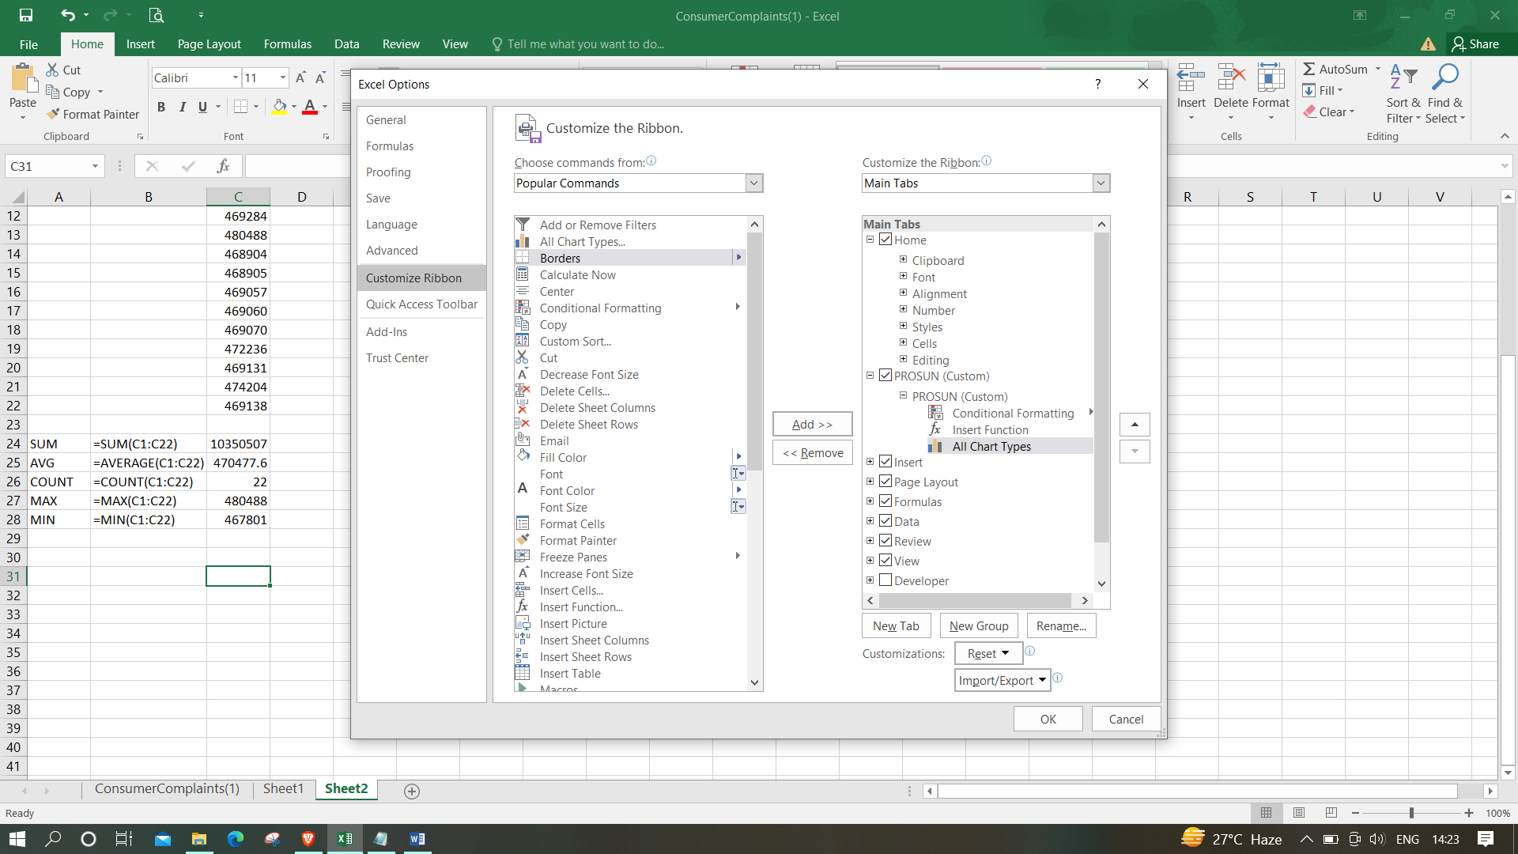

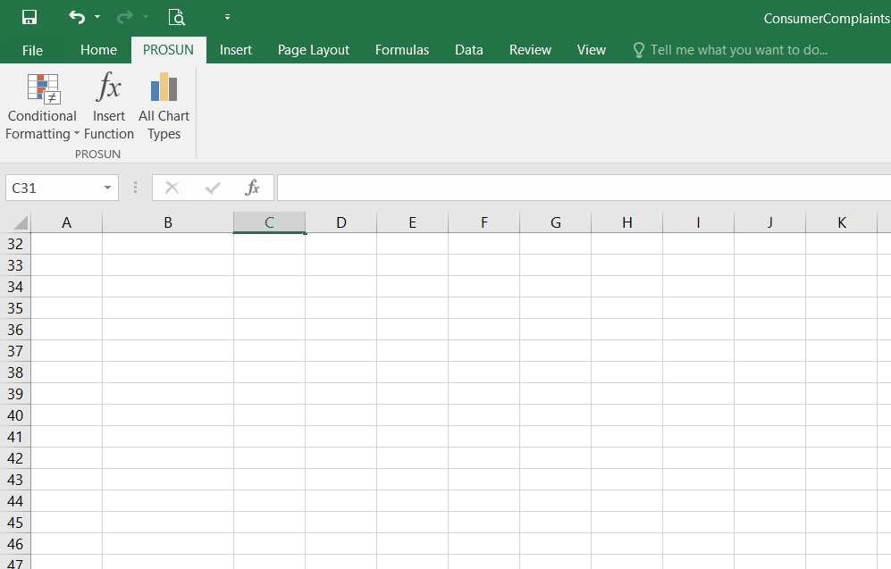

4. Make a list of different shortcut keys that are only connected to formatting with their functions.

***Ans:***

***Ctrl + L:****Aligns the line or selected text to the left of the screen.*

***Ctrl + E:****Aligns the line or selected text to the centre of the screen.*

***Ctrl + R:****Aligns the line or selected text to the right of the screen.*

***Ctrl + M:****Indent the paragraph.*

***Ctrl + Shift + F:****Change the font.*

***Ctrl + Shift + >:****Increase selected font +1pts up to 12pt and then increases font +2pts.*

***Ctrl + ]:****Increase selected font +1pts.*

***Ctrl + Shift + <:****Decrease selected font -1pts if 12pt or lower, if above 12 decreases font by +2pt.*

***Ctrl + [:****Decrease selected font -1pts.*

***Ctrl+Shift+A****→ Format all letters as capitals.*

***Ctrl+B****→ Applies or removes bold formatting.*

***Ctrl+I****→ Applies or removes italic formatting.*

***Ctrl+=****→ Apply subscript formatting (automatic spacing).*

*etc.*

5. What distinguishes Excel from other analytical tools?

*Ans:*

*Microsoft Excel is a useful tool for the businesses. Companies use the software to organize the data and maximize returns on investment. The large scale organizations have great volume of data from different resources like online sales, in store transactions and the social media. It is important to analyze this information in an efficient manner.*

*The excel spreadsheet displays financial information in an organized manner. The information could be related to the sales, management department, HR or the marketing. Most of the businesses are dependent on IT sector and therefore excel is a vital tool to run a business. Read on to learn about the topmost features of this software.*

* *It builds the charts*
* *It makes use of conditional formatting*
* *It helps to organize the data*
* *It will identify trends*
* *It provides online access*

*Excel will use range of formulas to unlock the potential of data. You have to insert data in individual cells of columns and rows. In this way, data will be filtered and sorted and hence displayed in a presentable manner. Different types of charts like clustered columns, graphs and pie chart provide great visual presentation. It puts more emphasis to marketing material and business reports. Excel is a wonderful tool to represent data on X and Y axis.*

*It provides different colour shades, font types to format the spreadsheet and differentiate between rows and columns. It is good to present useful presenting information such as balance, tax profit etc. There is a quick analysis button to choose the appropriate colouring scheme.  
  
You could combine the information from different files and documents to Excel. In this way, they will exist in a single location. Besides the regular information and raw data from spreadsheets, it is easy to import the images too. You just need to use the insert tab to add multiple objects to the spreadsheet.*

*It offers great online access. The employees as well as the business leaders can have access to this useful program from different location and from various devices. All they need is a web- enabled computer or laptop devices. There are many other extraordinary features of Microsoft excel.  
There are many benefits of using the software application as PDF to Excel converter. They do not have much compatibility issues and lesser storage is required to keep the files safe. All your files will remain safe and secure from unauthorized access. It is brilliant software that can help you to save money on other costly software applications.*

*The worst thing about expensive applications is they do not deliver results at times. If you are a start-up or a small business owner you might find it difficult to manage this software. In case you are stuck using the modified PDF converter, clear instructions are mentioned on the tab. Hence, even if you are not well versed in the technology, you can still use this application.*

6. Create a table and add a custom header and footer to your table.

1. Go to Insert > Header or Footer.

2. Choose from a list of standard headers or footers, go to the list of Header or Footer options, and select the header or footer that you need.

3. Select Close Header and Footer or press Esc.

